

Contents

From the Chief…………………………………………………… 1

Hail and Farewell……………………………………………….. 6

Lean Six Sigma Green Belt Training Opportunities 7

Catalog Tidbits…………………………………………………… 8

Personal Property Corner……………………………........ 9

Property Reutilization and Disposal Section (PRDS) Highlights……………………………………………….. 13

2017 PPMC Meeting Schedule…………………………… 16

NIH Annual Property Inventory Progress for 2017 17

NIH Property Management Training Schedule…… 18

Training Website References……………………………… 18

Points of Contact……………………………………………….. 19

Property Website References……………………………. 20

[1]NEWSLETTER STAFF



Editor: James Keisler

Phone: 301.435.3945

Email: [James.Keisler@nih.gov](mailto:James.Keisler@nih.gov)

From the Chief

Greetings Property Professionals, first and foremost, I’d like to wish everyone a Happy and healthy New Year! The 2017 physical inventory at the National Institutes of Health (NIH) began (January 10) and will continue through September 30th. The goal is to conduct a successful annual inventory in a professional manner with minimal disruption to the significant, ongoing work at the NIH. As of December 31, 2016, all remaining unresolved overages and shortages from the 2016 NIH annual inventory have transferred from current status to prior inventory long term tracking, e.g. - overages since 2002 and shortages since 2010 (U09). This information will be updated weekly as overages and shortages are reconciled.

The NIH has made tremendous strides in the accountability of our property assets and I thank you for your efforts! For the CY 2016 annual inventory, 98.57% of accountable property assets were reconciled (assets located during inventory + assets reported as lost, damaged or destroyed on a Report of Survey

(Continued on page 2)

(ROS)/total number of assets in accountable record) and 99.98% of assets were reconciled based on acquisition value (Value of assets located during inventory + value of assets reported on a ROS as lost, damaged or destroyed/total value of assets in accountable record). Since the property transformation in 2010, we’ve seen a 7.57% decrease in the annual inventory discrepancy rate. I attribute this success to the hard work of Institute and Center (IC) Property Accountability Officers (PAOs), IC Property Custodial Officers (PCOs), collaboration among the property community and the Property Management Branch (PMB) (e.g. best business practices). Although tremendous strides have been achieved, there is always room for improvement. I encourage you to continue reconciling shortages and overages identified from annual inventories. If you have questions in regards to reconciling your shortages and overages, please contact your assigned Inventory Management Specialist here in PMB for resolution.

From the Chief (Continued)

**PMB Updates**

**Personal Property Management Guide (PPMG)**

The review of the PPMG has made it through the Office of Management Assessment (OMA) and is currently being staffed for final stages of approval (final review and ending with approval and signature by the NIH Deputy Director for Management (DDM)). As soon as the guide is approved, PMB will forward a copy to all IC PAOs.

**Property Management Portal Project**

PMB, along with the National Institute of Allergy and Infectious Diseases (NIAID), briefed the Property Management Portal (PMP) project to the NIH Executive Officers (EOs) on November 15, 2016.

* November 18, 2016 - PMB provided a Property Management Portal information paper to the EOs which addressed the problem, background, discussion, and next steps.
* December 7, 2016 - PMB socialized the Property Management Portal Project Update to the NIH Property Community during the quarterly Personal Property Management Council (PPMC) meeting.
* December 8, 2016 - PMB forwarded an email to the Deputy EOs which discussed the Property Management Portal Project Update (Deputy EOs were briefed on this initiative, July 26, 2016).
* PMB asked the Deputy EOs that if ICs are interested in opting-in on this initiative, to identify one individual as a central point of contact and forward that information to PMB (Michael Fratina) in order to centralize communications and streamline the information flow throughout the NIH community.

(Continued on page 3)

* PMB also forwarded the email to IC PAOs to keep them informed.

From the Chief (Continued)

* PMB along with NIAID will conduct a working group in the near future with those interested ICs, we will also accommodate property portal briefings and demonstrations to IC leadership upon request.
* The PMP will place the responsibility at the user level and further facilitate accountability for property as follows:
* All staff will have direct access to their property records;
* Allows users to know which property is assigned to their name within the system of record (Sunflower);
* Automatic email notifications to property users when changes occur against the individual property record;
* Creates electronic validation of property by Accountable Users;
* Accountable User will develop an increased awareness and accountability for government property;
* Facilitate open communication between the IC community and the IC PAO / IC PCO;
* Reconcile discrepancies; and
* Can also be utilized as a “Pre-Inventory” tool prior to the annual inventory which will mitigate overages and shortages.

**PMP Next Steps**



The goal for the PMP are for all Institutes and Centers to utilize as an option to “opt-in.” (Implementation of the Property Management Portal is not mandatory, ICs can choose to opt-in or not). The potential benefits of the Property Management Portal Project will enable NIH to efficiently integrate and facilitate a timely audit and reconciliation of assets pre/post inventory and mitigate accountability discrepancies.

* Numerous ICs have already expressed an interest in attending the PMP Working Group.
* To date, PMB & NIAID received 3 requests from ICs (NIA, NCI & NHGRI) for a Property Portal briefing and demonstration to their leadership.
* Phase 1 is to clean up the records and to verify that assets are or are not in a given property user’s possession (as annotated in the system of record, Sunflower).
* If your IC is interested in receiving a Property Portal briefing and demonstration to your leadership, please contact me at [Michael.fratina@nih.gov](mailto:Michael.fratina@nih.gov).
* Additional details regarding activities and dates (i.e., project software development is complete; working group, pilot program/training dates, and full implementation date) will be provided as they become available.

(Continued on page 4)

**Reminders**

From the Chief (Continued)

****Please ensure acquisition costs are verified on the property record within Sunflower to reflect the property item’s actual acquisition cost. If there are differences, I would recommend IC PAOs and IC PCOs partner with respective IC procurement specialists, buyers, etc. to ensure the correct cost of the asset(s) is identified and entered correctly at the front end of the purchase (with the correct Object Class Code, 31), or the asset’s value is corrected at the receiving point when the item is received. These actions will mitigate cost variances, which have been identified by the NIH Internal Audit Team.

**NIH Annual Inventory**

In an effort to ensure effective communications and the best possible coordination of property matters, PMB will visit each IC building during the annual physical inventory of NIH accountable personal property. Inventory Management Specialists (IMS) from PMB will accompany the inventory team to each building with the intent of answering any property management policy questions and to serve as a liaison between the inventory team and the IC. The IMS will attend the entrance briefing, which is conducted at the start of inventory operations, in each new building and then accompany the inventory team during inventory operations that follow. IC PAOs and IC PCOs are encouraged to meet with the IMS and inventory team at the entrance briefing for each building and during the physical inventory of their assigned areas. Per December’s Personal Property Management Council (PPMC) Meeting, IC PAOs expressed an interest in knowing if they did not have representatives present during building openings. PMB will notify IC PAOs if IC representatives do not show up for the pre-briefing prior to the inventory commencing.

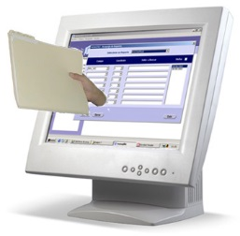**Capital Property Documentation Requirements in Sunflower**

Institutes and Centers are required to upload purchase order documents within the property system of record (Sunflower) for capital property assets (assets with an acquisition value of $25,000 and greater). Documents are also required (uploaded in Sunflower) for all cost adjustments for capital property assets prior to PMB approval. This practice will mitigate the NIH A123 Audit Deficiency finding: “Lack of review over fixed asset entries into Sunflower causing variances between the invoice and the asset value documented; acquisition and related supporting documentation for fixed assets are not adequately maintained”. This will also assist the Office of Financial Management prior to approving actions affecting the general ledger.

(Continued on page 5)

In closing, I want to pass along my sincere appreciation for your notable efforts in the managing of over 255,000 accountable property assets valued over $1.6 billion during the CY 2016 inventory and the professionalism you demonstrate daily. I strongly believe success is a result of communication and responsiveness; please do not hesitate to reach out to PMB for any questions or concerns. I wish you all a wonderful year and look forward to working with you in 2017!

From the Chief (Continued)

Michael B. Fratina Chief, Property Management Branch

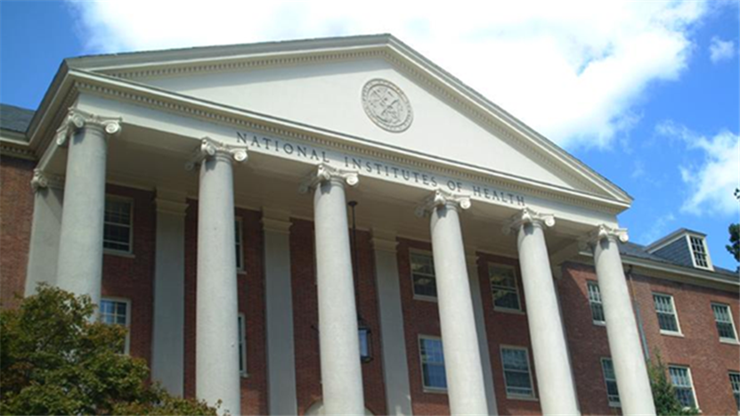

Hail and Farewell

The PMB takes pleasure in introducing new additions and sharing information regarding the changes to our team.

**Personnel changes within the Property Management Branch**

The Property Management Branch is pleased to introduce Mr. Andy Holmes and Mrs. Amanda Canada as Inventory Management Specialists within the Property Management Branch. Both Andy and Amanda join our team and bring with them extensive logistics experience in inventory management and property administration.

Please join us in welcoming Andy and Amanda as we are sure they will be instrumental in their future endeavors supporting the Property Management Branch’s efforts to serve the needs of the NIH property community.

Photograhs of new staff members assigned to the Property Management Branch.
From Left to right:  Mr. Andy Holmes and Mrs. Amanda Canada, Inventory Management Specialists.



Congratulations to Mr. Corey Thomas, who recently accepted a position to serve within the Property Management Branch at the Center for Disease Control and Prevention (CDC). Having joined the NIH PMB team in early 2011, Corey has been a valued member of our team serving as an Inventory Management Specialist within the Personal Property Section (PPS), and most recently as the Supervisor, Contract Property Section. His contributions to PMB have been tremendous and we wish Corey continued success in all of his future endeavors.



An information flyer providing information for Lean Six Sigma Training hosted by the Office of Logistics and Acquisition Operations.
Course information provided:
When:  The training will take place Monday, March 27 – Friday, March 31, 2017 from  8:30 AM - 4:30 PM.
Where: 6001 Executive Boulevard Rockville, MD – Training Room A.
Who: Enrollment is open to all federal NIH Employees. 
Class size is limited to 25 attendees 
Cost: $800 for the 5-day course that can be paid through a direct CAN citation to OLAO. There is an additional fee if interested in the 52 hours of project mentoring to become Green Belt certified. 
For more information, please e-mail LeanSixSigma@od.nih.gov

Lean Six Sigma Green Belt Training Opportunities

Catalog Tidbits



**Sonia E. Cross**

**(301) 435-3946**

[**sonia.cross@nih.gov**](mailto:sonia.cross@nih.gov)

The Sensitive Items List for Calendar Year 2017 below is being published and distributed to the NIH Property Community. There have been no changes to the list from last year. This list is to be used as a guide for our PAOs when determining the accountability of government property. The Property Management Branch reviews this list annually and makes changes based upon the DHHS Sensitive Items List and input from the NIH Property Community.

| **Category** | **Minimum Acquisition Threshold** | **Examples include but are not limited to:** |
| --- | --- | --- |
| Bio Safety Cabinets | No minimum acquisition cost | All types |
| Computers | No minimum acquisition cost | Includes PCs, Servers, Laptops, Computer Workstations, Tablets |
| Laboratory Grade Freezers | No minimum acquisition cost | Freezer Liquid Gas, Freezer Ultra-Low Temperature (upright, chest & bench top) |
| Liquid Scintillation Counters | No minimum acquisition cost | All types (portable, floor and bench top) |
| Smartphones | No minimum acquisition cost | iPhones, Blackberrys, Androids |
| Printers | No minimum acquisition cost | All types, does not include 3D Printers |
| Portable Instrumentation | $300.00 | Examples include Voltmeters, O-scopes, & Watt Meters |
| Power Tools | $300.00 | Includes stand-alone items such as Portable Compressors, Generators, Table Saws |
| Still Cameras | No minimum acquisition cost | Examples include Digital, Laparoscopic, & X-ray Identification |
| Televisions & Computer Monitors | No minimum acquisition cost | All Types, includes VoIP Monitors |
| Video Cameras | No minimum acquisition cost | Does not include surveillance equipment |
| Weapons | No minimum acquisition cost | Includes Firearms, Tranquilizer Guns, High-Voltage Stun Guns |
| Based on the Federal Management Regulation, a Sensitive item is defined as personal property items that do not meet the accountable item cost threshold ($5,000), but require special control and accountability due to; unusual rates of loss, theft or misuse, or due to national security or export control considerations. Such property includes weapons, ammunition, explosives, designated information technology equipment with memory capability, cameras, and communication equipment. | | |
| **January 1, 2017** | | |

Please feel free to contact me at [sonia.cross@nih.gov](mailto:sonia.cross@nih.gov), or by phone at 301-435-3946 if you have questions or concerns regarding this topic or any other Catalog related issues.

Sonia E. Cross

Property Systems Specialist

Personal Property Corner



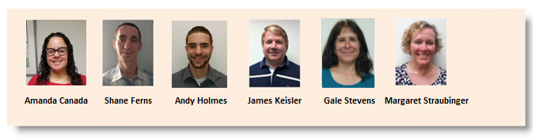**Inventory Management Specialists:**

**2017 Annual Inventory Update**

Now that the annual physical inventory process is complete for Calendar Year (CY) 2016, NIH IC Property Accountable Officers (PAOs) and IC Property Custodial Officers (PCOs) should have reconciled their property books in effort to resolve inventory shortages and overages. NIH currently has over 255,000 Accountable personal property assets with a value over $1.6 Billion. Interim shortages and 2016 CY overages are currently over 2,500 for CY16, and Declared Unaccounted assets (U09) from prior years and previous years overages are currently at 4,061 with a value over $37 million and still need to be resolved by corresponding ICs. The following information provides lists of recommended process actions that can be used by IC PAOs and IC PCOs to resolve inventory shortages and overages within their respective ICs.

**Inventory Shortages**

An inventory shortage occurs when an asset having an active property record in NBS Sunflower is not accounted for by physical inventory or by current pass in the NBS system.

**Reconciliation of Inventory Shortages**

Property Management Branch (PMB) recommends the following procedures for resolving inventory shortages:

(Continued on page 10)

* Review the current NBS property record to obtain details regarding the asset identified as a shortage.
* Contact the assigned User or Supervisor as defined by the property record to obtain information regarding the circumstances pertaining to the missing asset.

Personal Property Corner (Continued)

* Conduct a detailed sweep of the area where the asset was last associated; then, follow any leads regarding the whereabouts of the asset.
* Review any administrative files for expired/incomplete property records such as loans, property passes, repair passes, trade-in or warranty exchange transactions, or excess documentation.
* If a shortage is physically located, the asset must be scanned and uploaded sent to the Inventory Contractor in order to update the NBS record. If a scanner is not available within your IC, contact Christopher J. Batzel Sr. via Outlook or Phone at 310-594-2078 to request and schedule scanning assistance. Another option is to list shortages on an Excel spreadsheet listing all pertinent information (for additional information please contact myself) and a signed memorandum from the IC PAO must accompany this format stating all listed assets are correct, are located, and are within physical control of IC.

If after exhausting all search efforts, an asset remains unaccounted for, declare the asset as lost and resolve the matter by process of Report of Survey (ROS). A ROS is the only official process used to investigate the circumstances of the loss. The ROS also determines any liability requirements for those responsible for the loss. Finally, the ROS serves as the record adjustment documentation for the loss of government property.

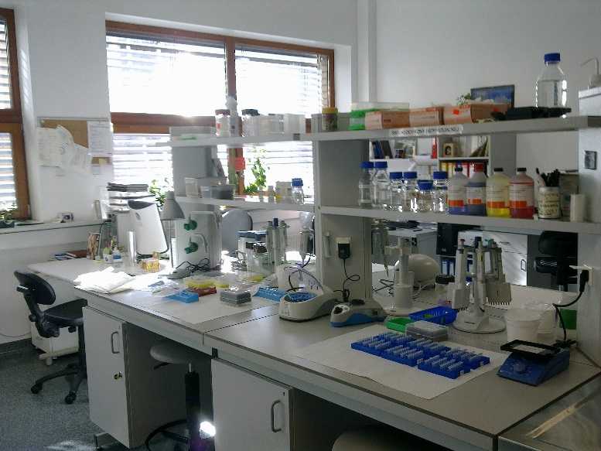

**Inventory Overages**

An overage is any accountable asset located by the inventory contractor during a physical inventory that is not on record in the NBS Sunflower property system. When an overage is identified, a decal label and a yellow dot will be affixed to the property asset and property information will be recorded (i.e., manufacturer, model, serial number and location) and sent from the inventory contractor to each IC PAO via their IC reporting tool on a weekly inventory report. The Overage reports accessible through the IC inventory reporting tool are updated weekly during the inventory. The report provides a cumulative listing of overage discoveries which are associated to the IC on account of their location and/or proximity to IC owned assets.

(Continued on page 11)

**Reconciliation of Inventory Overages**

Personal Property Corner (Continued)

The procedure for resolving inventory overages:

* When notified of an overage, make a visual inspection of the identified property to verify that it is your (NIH, IC) asset and not privately owned or contractor owned. If the asset is deemed contractor owned or privately owned the asset must be labeled accordingly.
* If after reviewing the asset you find the asset is the property of another IC, report the overage to the ICPAO for that IC and notify the Property Management Branch via your designated Inventory Management Specialist (IMS) liaison.
* If after examining the reported overage the property is determined to be non-government property (e.g., contractor owned); or the property is government owned and is determined non-accountable based on value, report such findings to your IMS liaison to have the item(s) removed from the overage list.
  + If the property belongs to your IC, search your NBS Sunflower decal worksheets to see if a skeletal record exists. If a skeletal record exists, ensure receiving actions are completed and pick up the asset through completing the decal worksheet process.
* When a skeletal record (decal worksheet) does not exist, the ICPAO/ICPCO should inquire with their purchasing agent(s) about the asset and inquiry why receiving actions have not been completed by the purchasing Agent(s).
* If no other conditions apply, the overage must be corrected by processing a manual add through the Sunflower module, but remember the manual add should only be made no decal worksheet or other supporting documentation exists.

When addressing inventory discrepancies, it is important to act promptly. Your assistance in resolving overages and shortages will yield improved accountability of assets and proper use of Taxpayer dollars.

For the 2017 NIH annual inventory the Inventory Contractor will continue to use the dot format for identification of an inventoried asset and assets that will require attention from the ICPCO/ICPAO.

An image of a green circle with the number 17 centered in the circle in bold white text.  The intent of the image is to provide a visual reference for the inventory dots/stickers  used to represent scanned non-capitalized assets.

Green with white numbers – Non-capitalized assets

An image of a purple circle with the number 17 centered in the circle in bold white text.  The intent of the image is to provide a visual reference for the inventory dots/stickers  used to represent scanned Capitalized assets.

Purple with white numbers – Capitalized assets

(Continued on page 12)

An image of a yellow circle with the number 17 centered in the circle in bold purple text.  The intent of the image is to provide a visual reference for the inventory dots/stickers used to identify assets found during the inventory, which are believed to be accountable, however are not currently listed within the accountable record.

Personal Property Corner (Continued)

Yellow with purple numbers – Accountable property not recorded

An image of a red circle or inventory dot sticker.  The intent of the image is to provide a visual reference for the inventory dots/stickers used to identify NIH assets or property that is no longer accountable and/or no longer meets sensitive criteria.  Decaled items with red inventory dots should maintain the decal label until disposed of by the Property Reutilization and Disposal Section (PRDS).

Red with NO numbers – Asset is no longer sensitive or accountable

(Decal barcode remains on asset until disposed of by PRDS).

In closing I want to personally thank all the IC PAOs/IC PCOs for a tremendous effort with regards to the 2016 annual inventory success. The Personal Property Section (PPS) looks forward to the upcoming 2017 CY NIH inventory and servicing all of your IC property action requirements. If you have any questions or need assistance regarding asset management or inventory related concerns, please do not hesitate to contact myself or your Property Management Branch Inventory Management Specialist (IMS).

Christopher J. Batzel Sr.

Supervisor, Personal Property Section



# A banner with photo images of Mike Kessler, Supervisor PRDS and Javier Arce-Colon, Property Disposal Section Specialist.Property Reutilization and Disposal Section (PRDS) Highlights

**PRDS Staff**



Greetings,

Property items coming through PRDS and then being re-deployed back to another IC that have not been scanned, will no longer be labeled as a shortage on the Inventory reports for the gaining IC. This is a policy change by the Chief, Property Management Branch to encourage reutilization of property items from the GDC by Institutes and Centers.

As of the time of this Newsletter, the GDC will be moving in the next year. No definitive answer has been obtained as to where or the timeline for this action. Due to our physical relocation, PRDS has shortened the hold time for property items coming into the Warehouse to reduce the number of potential property items that would require movement to another location. The timeframe is now: 21 days for Internal Screening by NIH; 14 days for Screening by Federal Agencies; 14 days for Screening by Direct Donation; declared to GSA for final disposition (up to 30 days for a response).

(Continued on page 14)

The Property Reutilization and Disposal Section (PRDS) has informed the Institutes and Centers who have had property items in storage for longer than 18 months that they must remove those items or surplus those items prior to the end of November of 2016. As of January 2017, there are still several IC’s with property remaining in storage. Please contact Mike Kessler if your IC remains with property at the GDC.

PRDS Highlights (Continued)

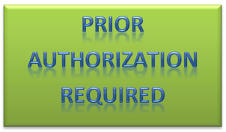IC PAOs/IC PCOs must complete an NIH form 2741 (Request to Cannibalize Personal Property) prior to any cannibalization occurring. This form is routed through PMB via your IMS liaison. Any piece of property received at the GDC that has been cannibalized without the proper form attached, will be sent back to the Institute and Center and a Board of Survey will need to be completed on that piece of property.

**Recycling and Reutilization Initiatives**

The NIH Recycling of Employee’s Personal Electronic Items started October 1, 2015 and is progressing well. Please pass the word within your Institute and Center about this program.

PRDS has many useable side chairs available for reutilization at the GDC Warehouse. Stop by and screen the 200 chairs now available. The sooner you screen the more options you will have. Remember, they are free!!

PRDS will be actively engaged in all NIH Green events such as America Recycles Day, Earth Day, and Green Labs Fair. We just completed America Recycles Week in November, which was a success. Earth Day occurred on April 22, 2016 last year and was very successful. Please prepare accordingly for upcoming recycling events as non-accountable recycle boxes and bins are usually staged at strategic points both on and off campus. Pick-up of the boxes/bins will occur after the event and items collected will be recycled through a GSA certified R2 Recycler.

All serviceable surplus property items at the GDC are free to NIH personnel and only require minimal paperwork. Please feel free to visit the PRDS and view our surplus property items which you might be able to utilize within your Institute or Center in lieu of procuring new assets. We can increase the amount of property items reutilized within the NIH with very little effort.

(Continued on page 15)

PRDS Highlights (Continued)

**FY16 Excess Property Items Redeployed Back to the NIH**

|  |  |  |
| --- | --- | --- |
| **Month** | **Items Processed** | **Acquisition Value** |
| October | 341 | $ 385,025.19 |
| November | 252 | $ 390,485.31 |
| December | 287 | $ 168,588.28 |
| **Total since October 1, 2016** | 593 | $ 775,510.50 |

If you have any questions please contact Mike Kessler by phone at (301)594-9915 or via email at [kesslerm@mail.nih.gov](mailto:kesslerm@mail.nih.gov).

Michael J. Kessler Sr.

Supervisor, Property Reutilization and Disposal Section



Cartoon images of a calendar hanging on the wall with pages of the month removed to represent the passing of time that correlates with scheduled events.PPMC Meeting Schedule

Mark your calendar for the next PPMC meeting...

When/where:

**Wednesday, March 1, 2017**

**Time: 10:00 AM to 11:30 AM**

**Location: Bldg. 45 Natcher Building,**

**Room F1/F2**

2017 PPMC Meeting Schedule

|  |  |
| --- | --- |
| March 2017  Wednesday  March 1, 2017  Time: 10:00 AM to 11:30 AM  Location:  Bldg. 45 Natcher Building, Room F1/F2 | June 2017  Wednesday  June 7, 2017  Time: 10:00 AM to 11:30 AM  Location:  Bldg. 45 Natcher Building, Room A |
| September 2017  Wednesday  September 6, 2017  Time: 10:00 AM to 11:30 AM  Location:  Bldg. 45 Natcher Building, Room A | December 2017  Tuesday  December 5, 2017  Time: 10:00 AM to 11:30 AM  Location:  Bldg. 45 Natcher Building, Balcony A |

The Property Management Branch values the insight of the NIH Property Community and encourages active participation during PPMC meetings. If there are any topics of interest that you would like to discuss at the PPMC meetings, please forward your suggestions to Michael Fratina at [michael.fratina@nih.gov](mailto:michael.fratina@nih.gov).

NIH Annual Property Inventory Progress for 2017

The annual property inventory commenced January 10, 2017. The scheduled inventory is provided for your information and planning purposes; the building sequence may be subject to change as the inventory progresses. Should changes become necessary, PMB will coordinate directly with the appropriate ICPAO. As the inventory progresses weekly emails will be sent, as in prior years, providing inventory progress and schedule updates.

Please refer to the following link for more information regarding the 2017 inventory schedule:

<http://www.nyt1.net/nih/ProgressUpdate/Info.asp>.

An Image of a Barcode label used decoratively to enhance the content of information regarding the annual inventory events.

NIH Property Management Training Schedule

|  |  |  |  |  |  |  |
| --- | --- | --- | --- | --- | --- | --- |
| **ID** | **Title** | **Dates\*** | **Location** | **Cancellation Deadline** | **Class Times** | **Tuition** |
| NIHTC  9517 | Introduction to NIH Property Management | Feb 15 - 17 | Rockledge I  6705 Rockledge Drive Room 4017 (RC2) | Feb 1 | 9:00 AM - 4:00 PM | $573 |
| NIHTC  9517 | Introduction to NIH Property Management | Apr 5 - 7 | Rockledge I  6705 Rockledge Drive Room 4017 (RC2) | Mar 22 | 9:00 AM - 4:00 PM | $573 |
| NIHTC  9517 | Introduction to NIH Property Management | Jun 21 - 23 | Rockledge I  6705 Rockledge Drive Room 4017 (RC2) | Jun 7 | 9:00 AM - 4:00 PM | $573 |

Training Website References

|  |  |
| --- | --- |
| Training | Links |
| NIH Training Center | <http://trainingcenter.nih.gov/list.aspx?catId=8> |
| NIH-Intro to Property Management | <http://trainingcenter.nih.gov/ShowDetails.aspx?cid=NIHTC9517> |
| Property Management Refresher | <http://trainingcenter.nih.gov/ShowDetails.aspx?cid=NIHTC9520> |
| National Property Management Association | <http://www.npma.org/> |
| Graduate School Personal Property Management | <http://graduateschool.edu/> |

Decorative clip art image of a mind sprouting a tree like growth that opens into a book - the image illustrates growing knowledge.

Points of Contact

Intramural Points of Contact

|  |  |  |
| --- | --- | --- |
| **Intramural Liaison** | **Phone Number** | **Institutes and Centers** |
| Amanda Canada | 301.496.3898 | NCATS, NIBIB, NIDCD, NIMHD,NINR |
| Shane Ferns | 301.496.6606 | SF, NCI, NEI, NHLBI, NICHD |
| Andy Holmes | 301.435.3012 | CSR, FIC, NCCIH, NIAMS, NIGMS |
| James Keisler | 301.435.3945 | NIDA, NINDS, NLM, ODORFD, ORS |
| Gale Stevens | 301.496.4772 | CC, NIA, NIDCR, NIDDK, NIEHS |
| Margaret Straubinger | 301.496.3292 | NHGRI, NIAAA, NIAID, NIMH. OD |

Extramural Points of Contact

|  |  |  |  |
| --- | --- | --- | --- |
| **Extramural Liaison** | **Phone Number** | **COAC** | **Institutes and Centers** |
| Jerry Haley | 301.496.5609 | NCI | NCI, NCCIH |
| Allan Henderson | 301.496.4689 | NLM | NLM, CIT, OD, NIDDK |
| David Hubbard | 301.496.4366 | NICHD | NICHD, NIAAA, FIC |
| Marea Petrelles | 301.496.4485 | NHLBI | NHLBI, CSR, NIAMS, NIDCR, NIBIB, NHGRI |

|  |  |  |  |
| --- | --- | --- | --- |
| **Neuroscience Liaison** | **Phone Number** | **COAC** | **Institutes and Centers** |
| Jerry Haley | 301.435.5609 | NIDA | NIDA, NINDS, NIMH, NIA, NCATS |
| David Hubbard | 301.496.4366 | OLAO | NINR, NEI, NIDCD, NIGMS, NIMHD, OD, ORS, NITAAC, OLAO |
| Hannah Stachmus | 301.496.4180 | NIAID | NIAID, HHS Bio-defense |

|  |  |  |  |
| --- | --- | --- | --- |
| **Specialty Liaison** | **Phone Number** | **COAC** | **Institutes and Centers** |
| Allan Henderson | 301.496.4689 | CC, ORF, NIEHS | CC, ORF, NIEHS |

**Extramural Liaison**

**Extramural L**

# Property Website References

|  |  |
| --- | --- |
| **Websites[2]** | **Links** |
| NBS Portal (Regulations, Forms) | <https://mynbs.nih.gov/SitePages/NBS%20Home.aspx> |
| NIH Manual Chapters | <https://oma.od.nih.gov/DMS/Pages/Manual-Chapters.aspx> |
| Help Desk Ticket; for computer support | [http://ITServicedesk.nih.gov](http://itservicedesk.nih.gov/) |
| HHS Administrative Manuals | <https://web.archive.org/web/20111015044731/http:/www.hhs.gov/hhsmanuals/> |
| NIH Office of Logistics and Acquisition Operations | [http://olao.od.nih.gov](http://olao.od.nih.gov/) |
| Government Accountability Office | <http://www.gao.gov/> |
| GSA Personal Property policies | <http://www.gsa.gov/portal/content/104604> |

1. PMB encourages IC’s to submit property related articles. PMB will do their best to include submitted articles in future newsletters. Please submit articles to James Keisler.
2. Accessibility

   The Office of Logistics and Acquisition Operations, OLAO, is making every effort to ensure the information available on our website is accessible to all. OLAO is not responsible for the accessibility of the websites listed within this newsletter. To learn more about the regulations governing the accessibility of Federal electronic information products, visit the [Section 508 page](http://www.section508.gov/).